MINI PROJECT REPORT ON

RESUME BUILDER USING PYTHON AND DJANGO

COVERPAGE
MINI PROJECT REPORT ON

RESUME BUILDER USING PYTHON AND DJANGO
Submitted By
C.NAVEEN
Department
Electrical and Electrical Engineering
Submitted to
Annamacharya Institute of Technology and Sciences, Tirupati
Academic Year
2026–2027

CERTIFICATE
This is to certify that the project entitled “Online Resume Builder Using Python and Django” submitted by C.Naveen, is a genuine work carried out during the academic year 2026–2027 as part of the curriculum requirements of the Bachelor of Technology program.
This project is the result of sincere efforts and technical work done by the student under proper guidance and supervision. The work presented here is original and has not been submitted elsewhere for the award of any degree.
We wish the student success in all future academic and professional attempts.

ACKNOWLEDGEMENT
I would like to express my sincere gratitude for the opportunity to complete my mini project titled “Online Resume Builder Using Django” as part of my CRT placement training.
I take this opportunity to sincerely acknowledge with effort and dedication in successfully designing, developing, and completing this project. This project helped me enhance my practical knowledge in Python, Django framework, and web development, and also improved my problem-solving and technical skills.
I am thankful for the learning experience gained throughout the development process, which allowed me to understand real-time project implementation, database handling, and dynamic web application development.
Finally, I am grateful to my institution for providing the platform and resources required to complete this mini project successfully.

ABSTRACT
The Resume Builder Using Python and Django is a web-based application designed to simplify the process of creating professional resumes.
In today’s competitive world, a well-structured resume is essential for job opportunities. Many users struggle with formatting and designing resumes manually. This system provides an automated solution where users can simply enter their details and generate a professional resume instantly.

Key Features:
- User registration and login system
- Easy data entry forms
- Multiple resume templates
- Automatic resume generation
- PDF download option
- Secure data storage
This project reduces manual effort and saves time while ensuring professional-quality resume output.

TABLE OF CONTENTS
- Introduction
- Problem Statement
- Objectives
- Existing System
- Proposed System
- Technologies Used
- Project Code Explanation
- System Requirements
- System Architecture
- Modules
- Database Design
- Implementation
- Screenshots
- Advantages
- Limitations
- Future Scope
- Conclusion
- References

CHAPTER 1: INTRODUCTION
The Resume Builder is a web-based application developed using Python and Django framework. It is designed to help users create professional resumes easily without requiring advanced technical or design skills.
A resume is an important document used in job applications. Traditionally, resumes are created using MS Word or online tools, which require formatting knowledge. This project simplifies the process by automating resume creation.

Importance of the System:
- Saves time for users
- Eliminates formatting errors
- Provides ready-made templates
- Improves presentation quality
The system is user-friendly and accessible from anywhere with an internet connection.

CHAPTER 2: PROBLEM STATEMENT
In the traditional method, resume creation is manual and time-consuming. Users often face difficulties in formatting and structuring content properly.

Major Problems:
- Time-consuming manual resume creation
- Lack of professional formatting skills
- Difficulty in editing and updating resumes
- Dependence on external tools or templates
- Limited design knowledge among users
Due to these issues, many users are unable to create effective resumes.
The proposed system solves these problems by providing an automated, easy-to-use platform.

CHAPTER 3: OBJECTIVES
The main objectives of this project are:
- To develop an online resume builder application
- To allow users to create resumes easily
- To provide secure login and registration system
- To generate resumes in professional format
- To support PDF download functionality
- To store user data securely in database
- To offer multiple resume templates
- To reduce time and effort in resume preparation

CHAPTER 4: EXISTING SYSTEM
In the existing system, resumes are created manually using tools like MS Word or online editors.

Characteristics:
- Manual formatting required
- No automation
- Time-consuming process
- Frequent formatting errors
- Limited professional designs in free tools

Limitations:
- Requires technical knowledge
- Not user-friendly for beginners
- Difficult to maintain multiple versions
- Lack of centralized data storage

CHAPTER 5: PROPOSED SYSTEM
The proposed system is a web-based Resume Builder developed using Django framework.

Features:
- User authentication system
- Resume creation form
- Multiple templates for resumes
- Instant PDF generation
- Secure database storage
- Easy navigation dashboard

Advantages:
- Simple and fast process
- Professional output
- Easy editing and updating
- Secure and reliable system
- Accessible anytime

CHAPTER 6: TECHNOLOGIES USED

Python:
Python is used as the backend programming language. It is simple, powerful, and widely used in web development.

Django:
Django is a high-level Python framework that helps in building secure and scalable web applications.

HTML:
Used for creating the structure of web pages.

CSS:
Used for designing and styling the user interface.

SQLite:
A lightweight database used to store user and resume data.

xhtml2pdf:
A Python library used to convert HTML pages into PDF format.

CHAPTER 7: PROJECT CODE EXPLANATION
The Resume Builder project is developed using Python and Django framework. The application follows the MVC (Model-View-Controller) architecture provided by Django, where models handle database, views handle logic, and templates handle UI.

7.1 Project Structure
The project consists of the following main components:
- resumebuilder (Project Folder) → Contains main settings and configuration.
- resumeapp (Application Folder) → Contains models, views, URLs, and business logic.
- templates folder → Contains HTML files for UI design.
- static/assets folder → Contains CSS, JavaScript, and images.
- db.sqlite3 → Default database file used by Django.

7.2 Models (models.py)
Models define the database structure.
User Table stores login details:
- username → stores user name
- email → stores email address
- password → stores encrypted password
Resume Table stores resume data:
- name → full name of user
- email → email address
- phone → contact number
- education → educational details
- experience → work experience
- skills → technical skills
- template → selected resume template
Django automatically converts these models into database tables using migrations.

7.3 Views (views.py)
Views control the logic of the application.
Main functions include:
- Displaying homepage
- Handling template selection
- Processing resume form data
- Rendering resume preview
- Generating final resume output
Views receive user input, process it, and return HTML responses.

7.4 URLs (urls.py)
URLs map web pages to their corresponding views.
Example:
- / → Home page (template selection)
- /form → Resume form page
- /preview → Resume preview page
Django uses URL routing to connect frontend requests with backend logic.

7.5 Templates (HTML Files)
Templates define the user interface.
- index.html → Template selection page
- form.html → Resume input form
- template1.html → Professional resume design
- template2.html → Modern resume design
Placeholders like:
{{name}}, {{email}}, {{skills}}
are replaced dynamically using JavaScript or Django rendering.

7.6 JavaScript Functionality
JavaScript is used for:
- Fetching template files dynamically
- Replacing placeholders with user input
- Generating live preview of resume
- Converting resume to PDF using jsPDF and html2canvas

7.7 PDF Generation
The final resume is converted into PDF using:
- html2canvas → Converts HTML to image
- jsPDF → Converts image to downloadable PDF file
This allows users to download their resume instantly.

7.8 Database Operations
Django uses SQLite database for storing user and resume details.
Operations include:
- Create → Saving new resume data
- Read → Displaying stored data
- Update → Editing resume details (future enhancement)
- Delete → Removing resume data (future enhancement)

7.9 Working Flow of Project
- User selects resume template
- User enters personal details
- Data is processed using JavaScript/Django
- Resume preview is generated
- User downloads resume as PDF

CHAPTER 8: SYSTEM REQUIREMENTS

Hardware Requirements:
- Processor: Intel Core i3 or above
- RAM: Minimum 4 GB
- Hard Disk: 20 GB or more
- Internet Connection

Software Requirements:
- Python 3.9 or above
- Django 4.x
- VS Code / PyCharm
- SQLite Database
- Windows 10/11

CHAPTER 9: SYSTEM ARCHITECTURE

User
↓
Login / Registration
↓
Dashboard
↓
Resume Form
↓
Database Storage
↓
Template Selection
↓
PDF Generation
↓
Download Resume

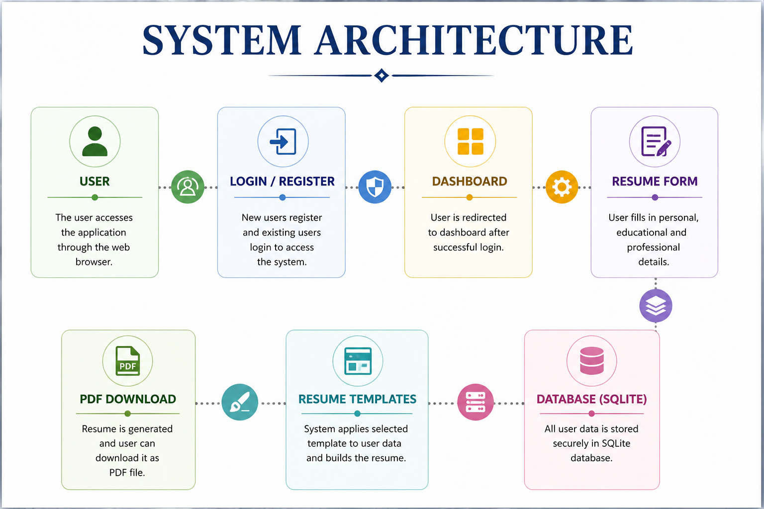

CHAPTER 10: MODULES

1. User Registration Module
Handles new user sign-up and account creation.

2. Login Module
Authenticates users and ensures secure access.

3. Dashboard Module
Displays available features and navigation options.

4. Resume Form Module
Collects personal, educational, and professional details.

5. Template Module
Provides different resume designs.

6. PDF Module
Converts resume into downloadable PDF format.

CHAPTER 11: DATABASE DESIGN

User Table:
- id (Integer)
- username (CharField)
- password (CharField)

Resume Table:
- name (CharField)
- email (EmailField)
- phone (CharField)
- address (CharField)
- profile (CharField)
- education (TextField)
- experience (TextField)
- skills (TextField)

Explanation:
The database stores user login details and resume information securely for future access and updates.

CHAPTER 12: IMPLEMENTATION

Steps:
- Created Django project
- Developed application modules
- Designed database models
- Created user input forms
- Developed HTML templates
- Configured URLs and views
- Integrated PDF generation
- Tested application functionality

Outcome:
A fully functional web-based resume builder system.

CHAPTER 13: SCREENSHOTS
SCREENSHOTS OF RESUME BUILDER USING DJANGO

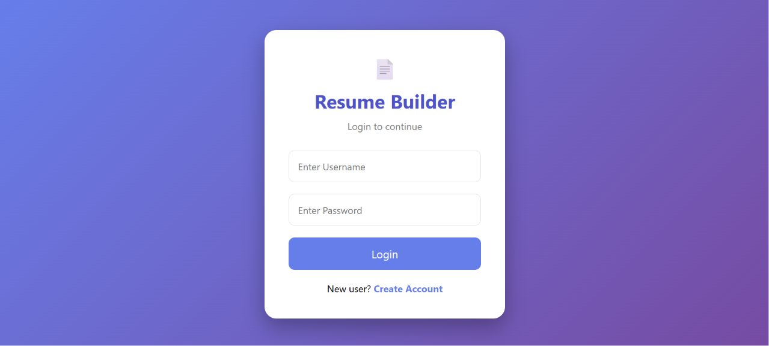

Figure 1: Login Interface

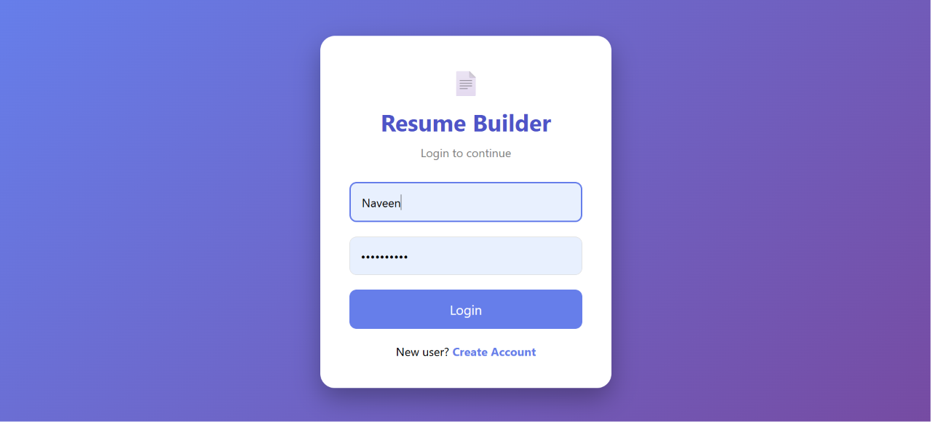

Figure 2: Login Details

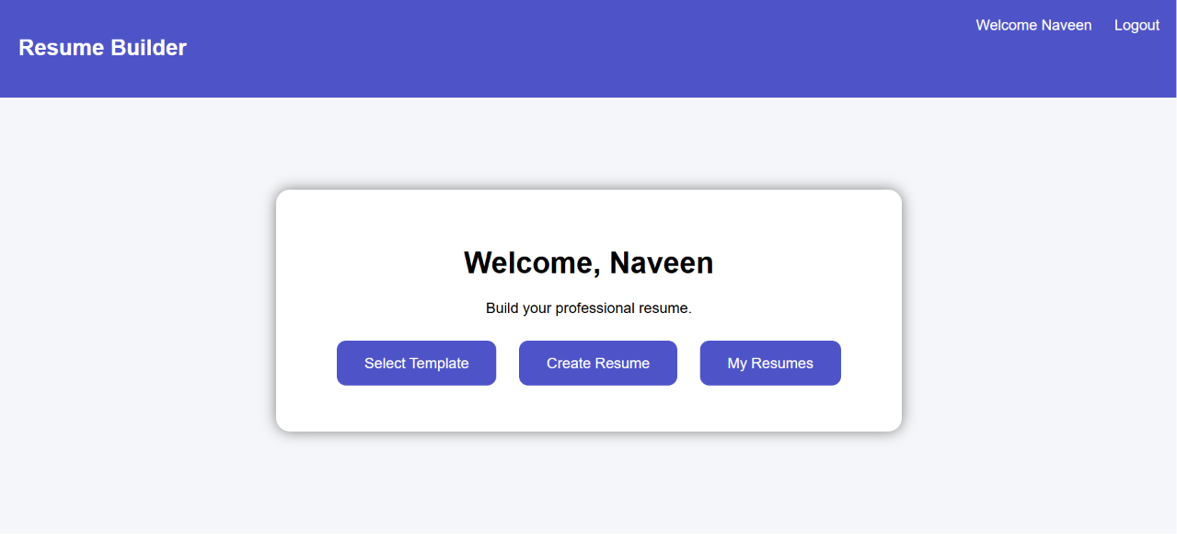

Figure 3: Resume Builder Interface

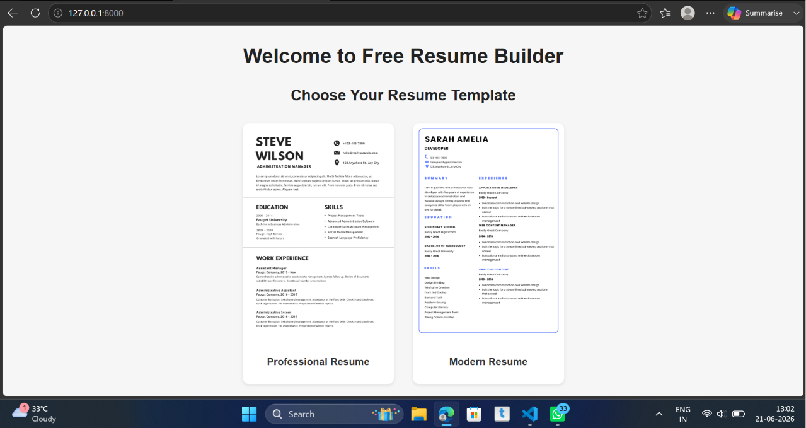

Figure 4: Templates
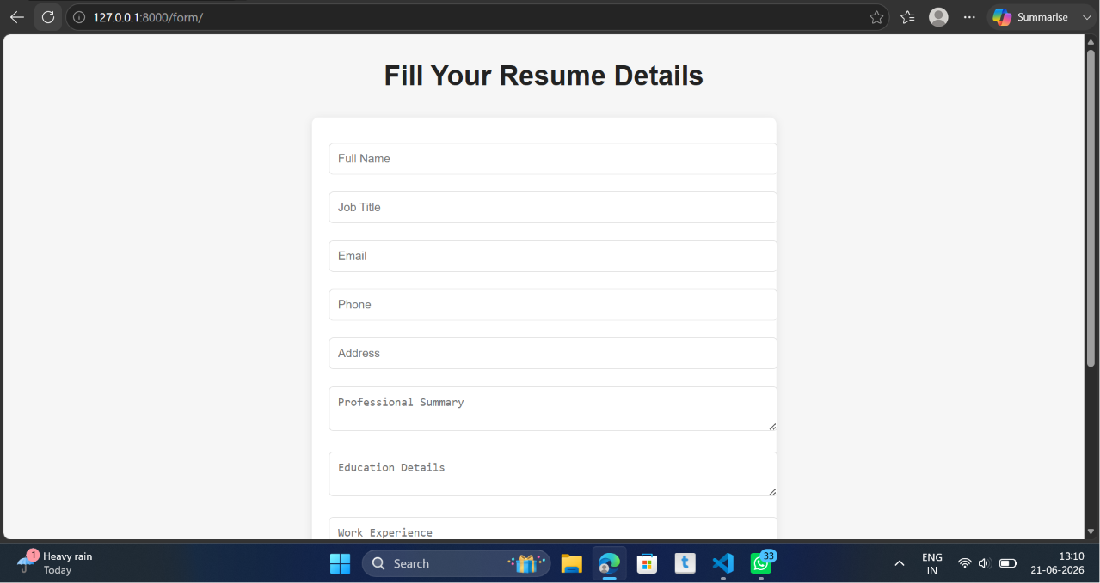

Figure 5 : Resume Details

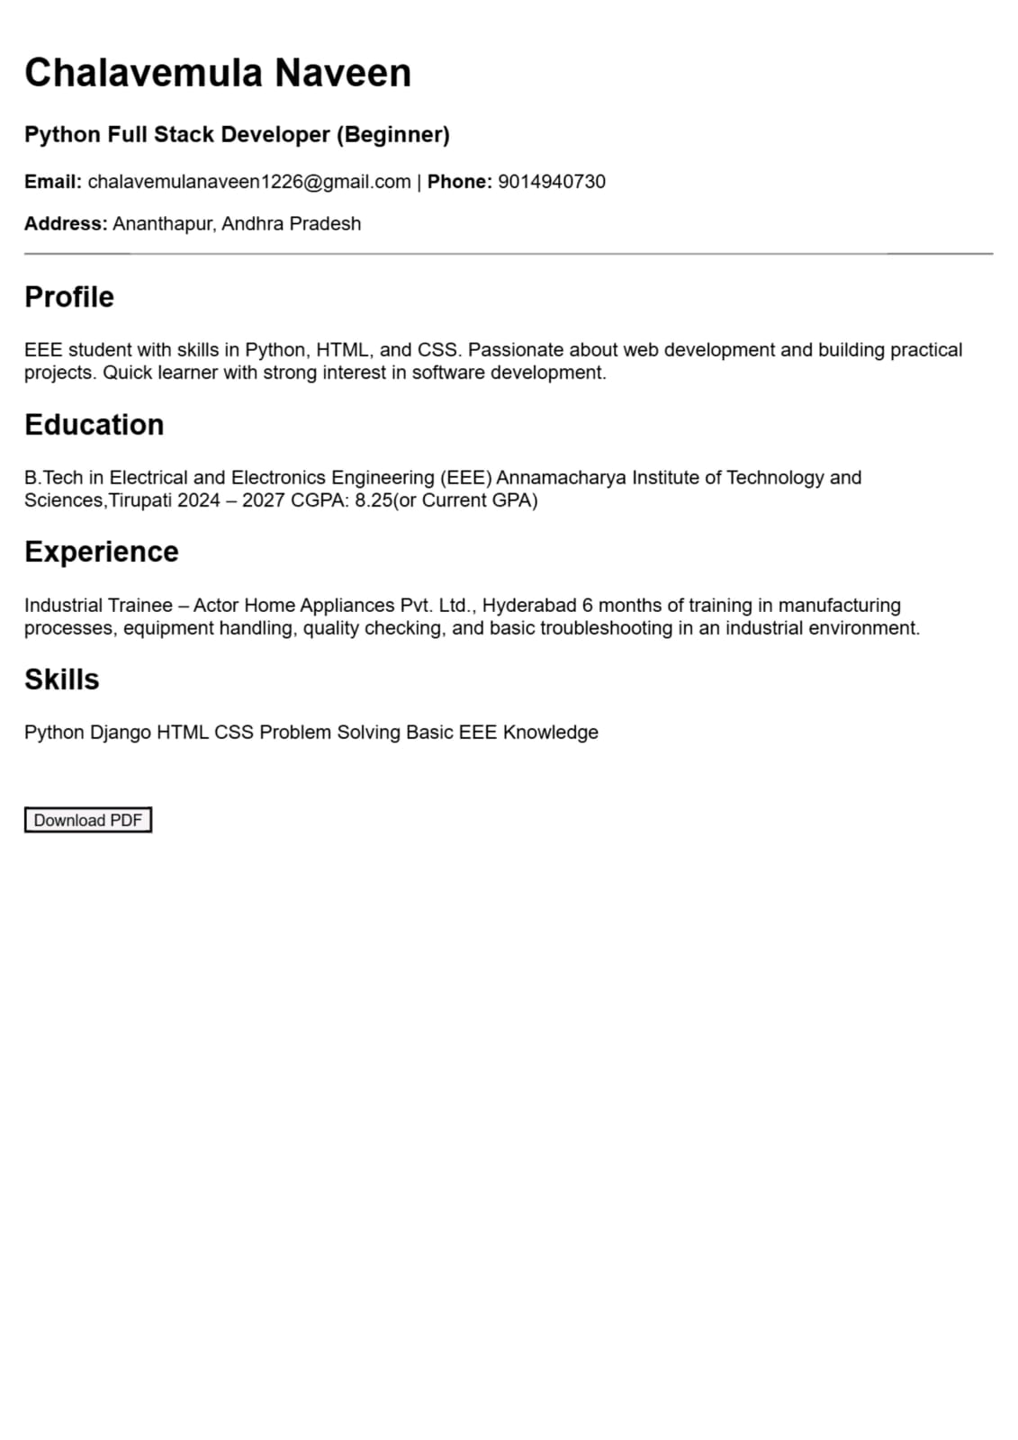
Figure 6: Resume Preview

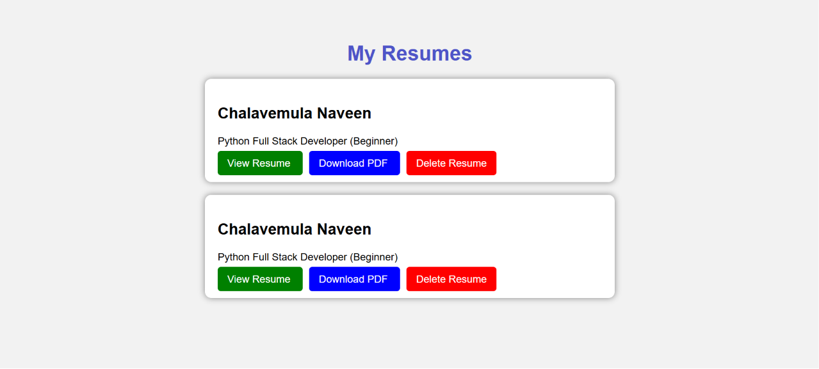

Figure 7: My Resumes

CHAPTER 14: ADVANTAGES
- Easy to use interface
- Saves time and effort
- Professional resume output
- Secure login system
- Multiple templates available
- Data stored safely
- Accessible anytime

CHAPTER 15: LIMITATIONS
- Limited number of templates
- Requires internet access
- Basic UI design
- No mobile application version
- No cloud integration

CHAPTER 16: FUTURE SCOPE
Future improvements can include:
- AI-based resume suggestions
- Profile photo upload feature
- Cloud storage integration
- Resume sharing via link
- Mobile application development
- More professional templates
- Email export feature

CHAPTER 17: CONCLUSION
The Resume Builder Using Python and Django is an efficient web application that simplifies resume creation. It provides users with an easy and fast way to generate professional resumes.
This project successfully demonstrates the use of Django framework in real-world application development. It reduces manual effort and improves productivity for students and job seekers.

CHAPTER 18: REFERENCES
- Python Official Documentation
- Django Official Documentation
- W3Schools (HTML & CSS Tutorials)
- SQLite Documentation
- xhtml2pdf Library Documentation

